I will honor Christmas in my heart and try to keep it all the year. – Charles Dickens

Dear colleagues, friends, everywhere
We send you our heartfelt wishes for a wonderful Christmas and Hanukkah season.
Thank you for your commitment and sharing. We continue to make huge progress in our fight against injustice of all kinds, and this year has been exceptional in challenges. The successes are too many to recount, and you all know who to thank! YOURSELVES, each other, and God above. May we be of peace and good will, and have the faith needed to bring a New Year of hope.
GOD BLESS. Happy New Year.
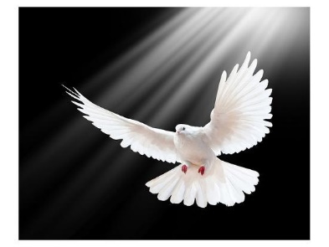Sherri Lange and Eric Rosenbloom
NA-PAW (North American Platform Against Wind Power.)

We wish to share this short music video with you, Andrea Bocelli and his son, Matteo, FALL ON ME. There are many metaphors to be taken from this exquisite piece. For us, it represents the sharing of leveraged strength and friendship, with caring individuals working together on common goals.

